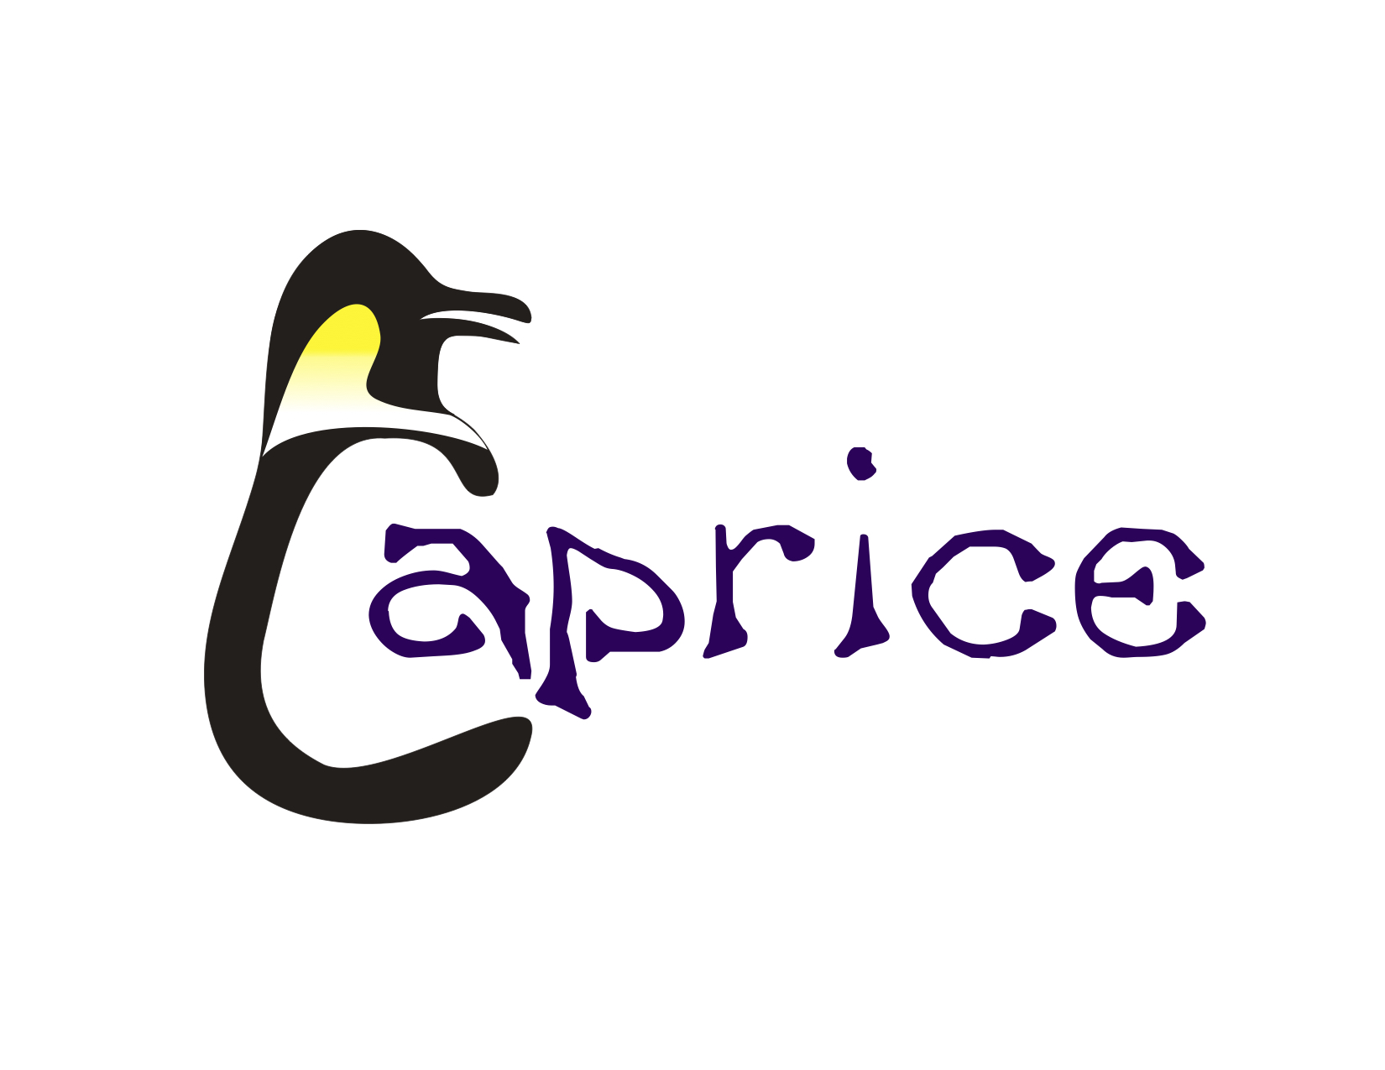
CAPRICE ARTISTIC SWIM CLUB REGISTRATION FORM
2020/2021

SWIMMER INFORMATION

Last Name: |  |  |  |  |  |  |  |  |  | First Name:
Date of Birth: |  |  |  |  |  |  |  |  | New competitive registrants must supply a photocopy of their Birth Certificate
Home Address:
City : |  |  |  |  |  |  |  |  |  | Postal Code:
Mother/Guardian: |  |  |  |  |  |  |  |  |  |  | Phone (H):
Work: |  |  |  |  |  |  |  |  |  |  | Cell:
Email:
Father/Guardian: |  |  |  |  |  |  |  |  |  |  | Phone (H):
Work: |  |  |  |  |  |  |  |  |  |  | Cell:
Email:
Emergency Contact: |  |  |  |  |  |  |  |  |  |  | Phone (H):
Work: |  |  |  |  |  |  |  |  |  |  | Cell:
Name of School:
Email of School:

MEDICAL INFORMATION

Family Doctor: |  |  | Phone:
Care Card Number
Allergies:
List all serious medical conditions:
Describe any past serious illnesses or injuries:

SWIM HISTORY

Previous Synchro experience: ☐ Yes ☐ No
Last Swim Kid Level: |  | Previous club (if not Caprice)
Years in Competition: |  | No formal training, check here:
Previous Synchro Level: ☐Aquasquirts ☐ Rec ☐ 10&U ☐12&U ☐13-15Novice ☐13-15 PS
☐16-18Novice ☐16-18 ☐Masters ☐National Stream 13-15 ☐National Stream Junior
Previous number of days for synchro practice: ☐1day ☐2days ☐3days ☐ 4days
Interest in increasing practice time: ☐Yes ☐No

PARENT/ GUARDIAN AGREEMENT

- Parent/Guardian – you and your child understand and agree to be bound by the BC Artistic Swimming Members’ Code of Conduct and CAPRICE ARTISTIC SWIM CLUB (CASC) and policies and recognize that this is intended to uphold the integrity of this organization and its members.
- I am the swimmer’s parent or guardian and I authorize the club to use photographs and video of the swimmer taken during practices or meets for use on any Caprice Artistic Swim Club promotional material or official website.
- I agree to pay the swimmer’s club fees, BC Artistic Swimming fees, fundraising deposit, family participation deposit, meet fees, team fees and all other costs including (but not limited to) travel, wardrobe, and equipment.
- I do hereby waive, release, absolve, indemnify and agree to hold harmless Caprice Artistic Swimming Club, the organizer’s, Board of Directors, sponsors, and Coaches of my child.
Name: |  | Signature: |  | Date:

SWIMMERS AGREEMENT

I,_______________________________________ wish to be a member of Caprice Artistic Swim Club and be a contributing member of my team. I have read, understood and agree to the CASC Swimmer’s Expectation Contract.

Name: |  | Signature: |  | Date:

Initial
I have read & agree to the BCSSA Policy & Handbook for Athletes & Parents.

I am aware of the BCSSA Injury Management Protocol.
Initial

(The BCSSA Policy & Handbook for Athletes & Parents as well as the BCSSA Injury Management Protocol can be found on the BCSSA webpage)

